Json Contract by Component.

- Agenda
URL: https://www.vmware.com/explore/us/attend/agenda.html
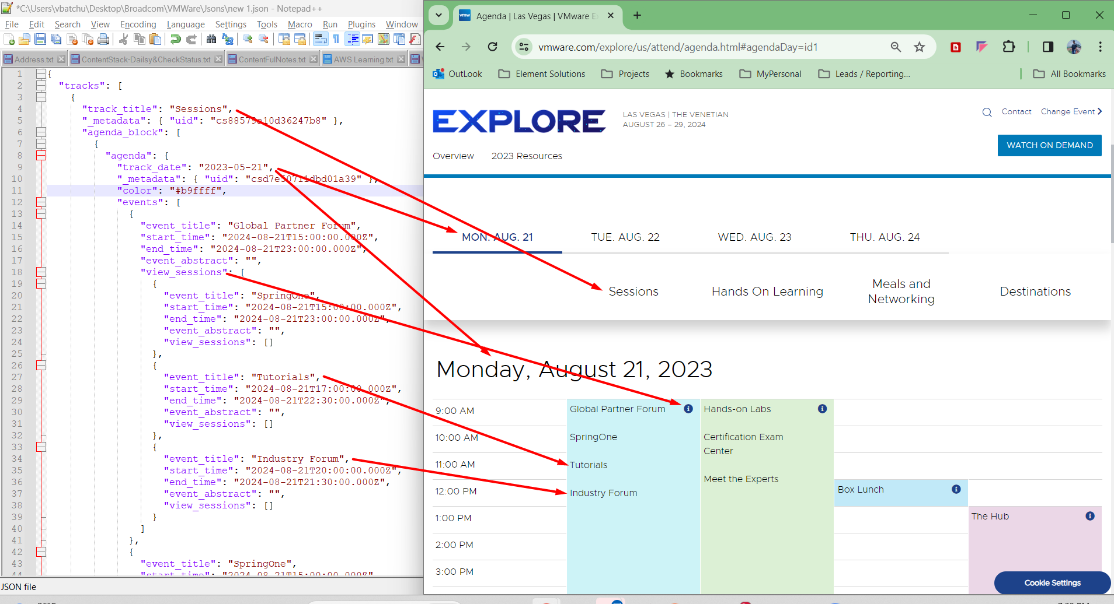

- Banner
URL: https://vmware.com/explore.html

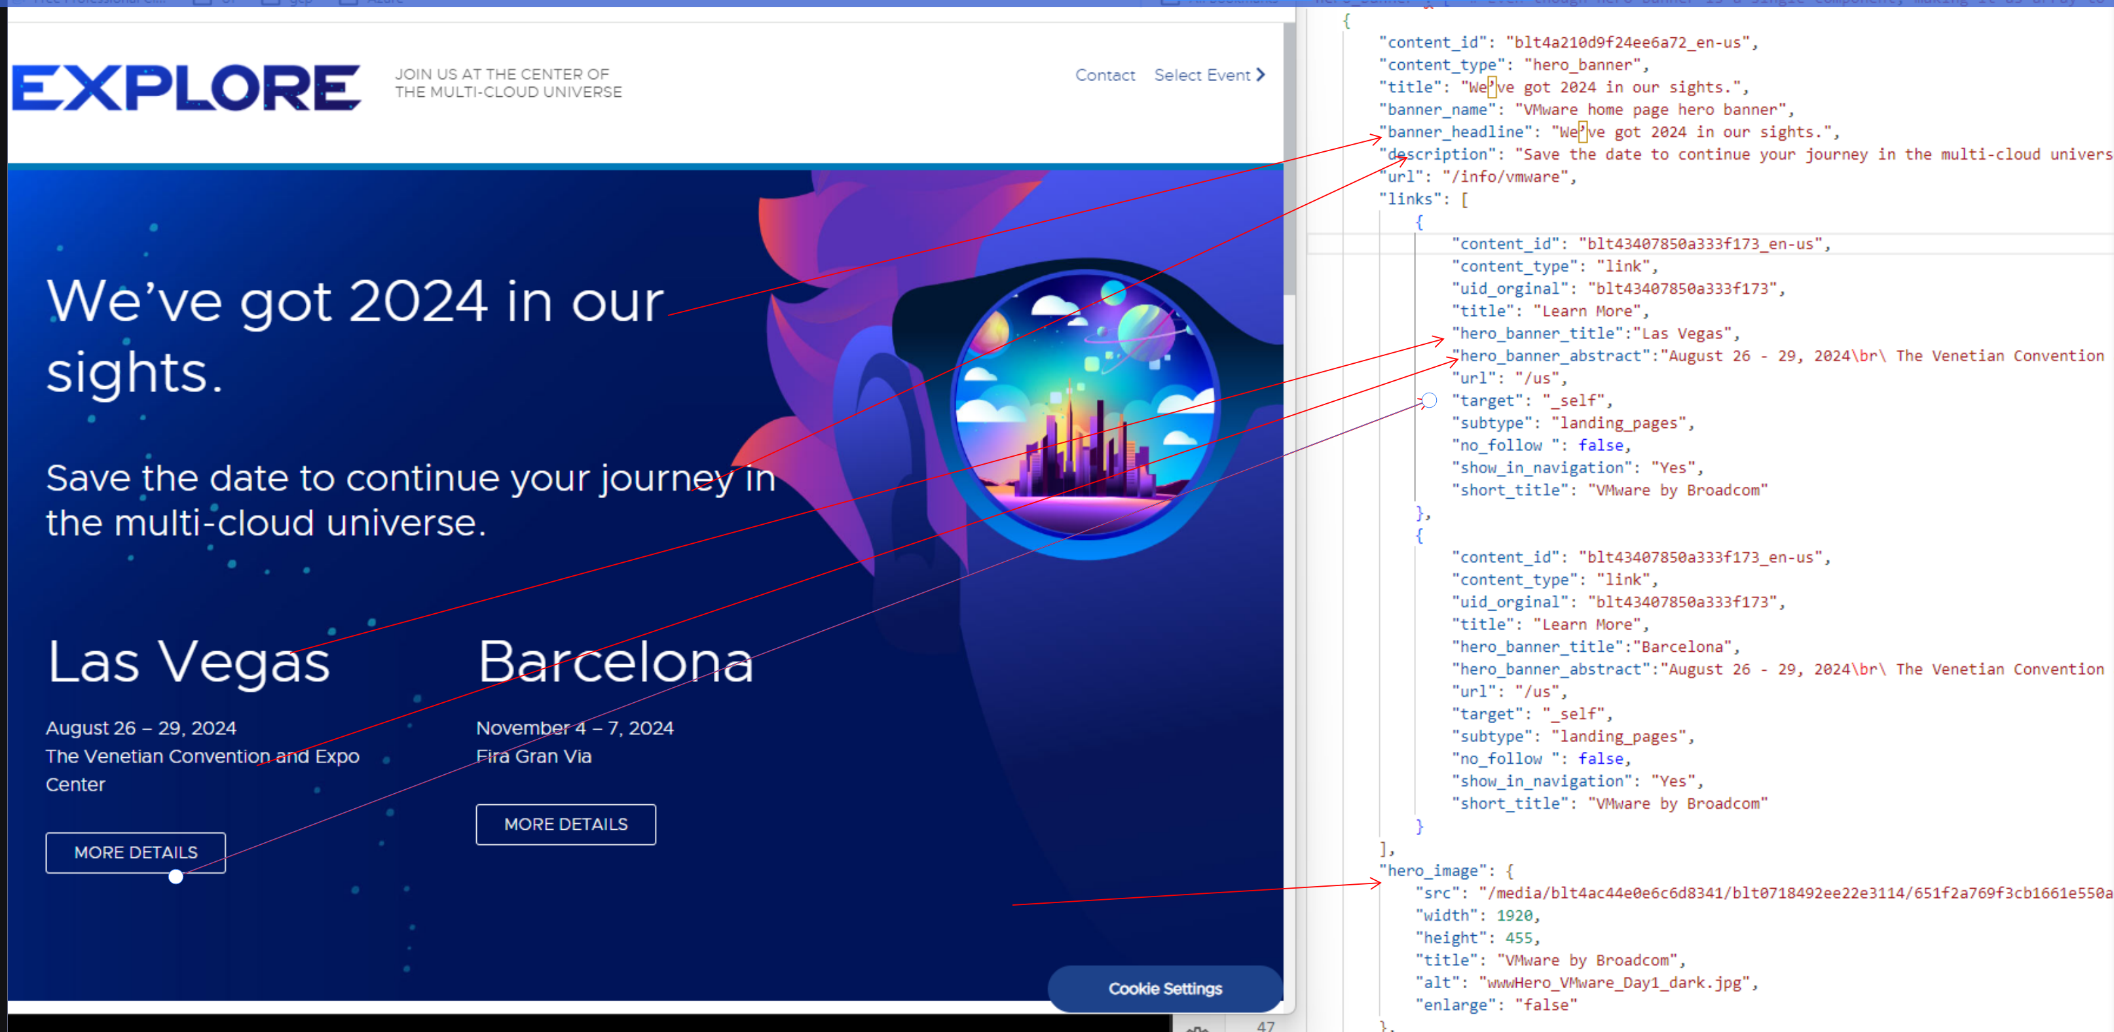

- Header

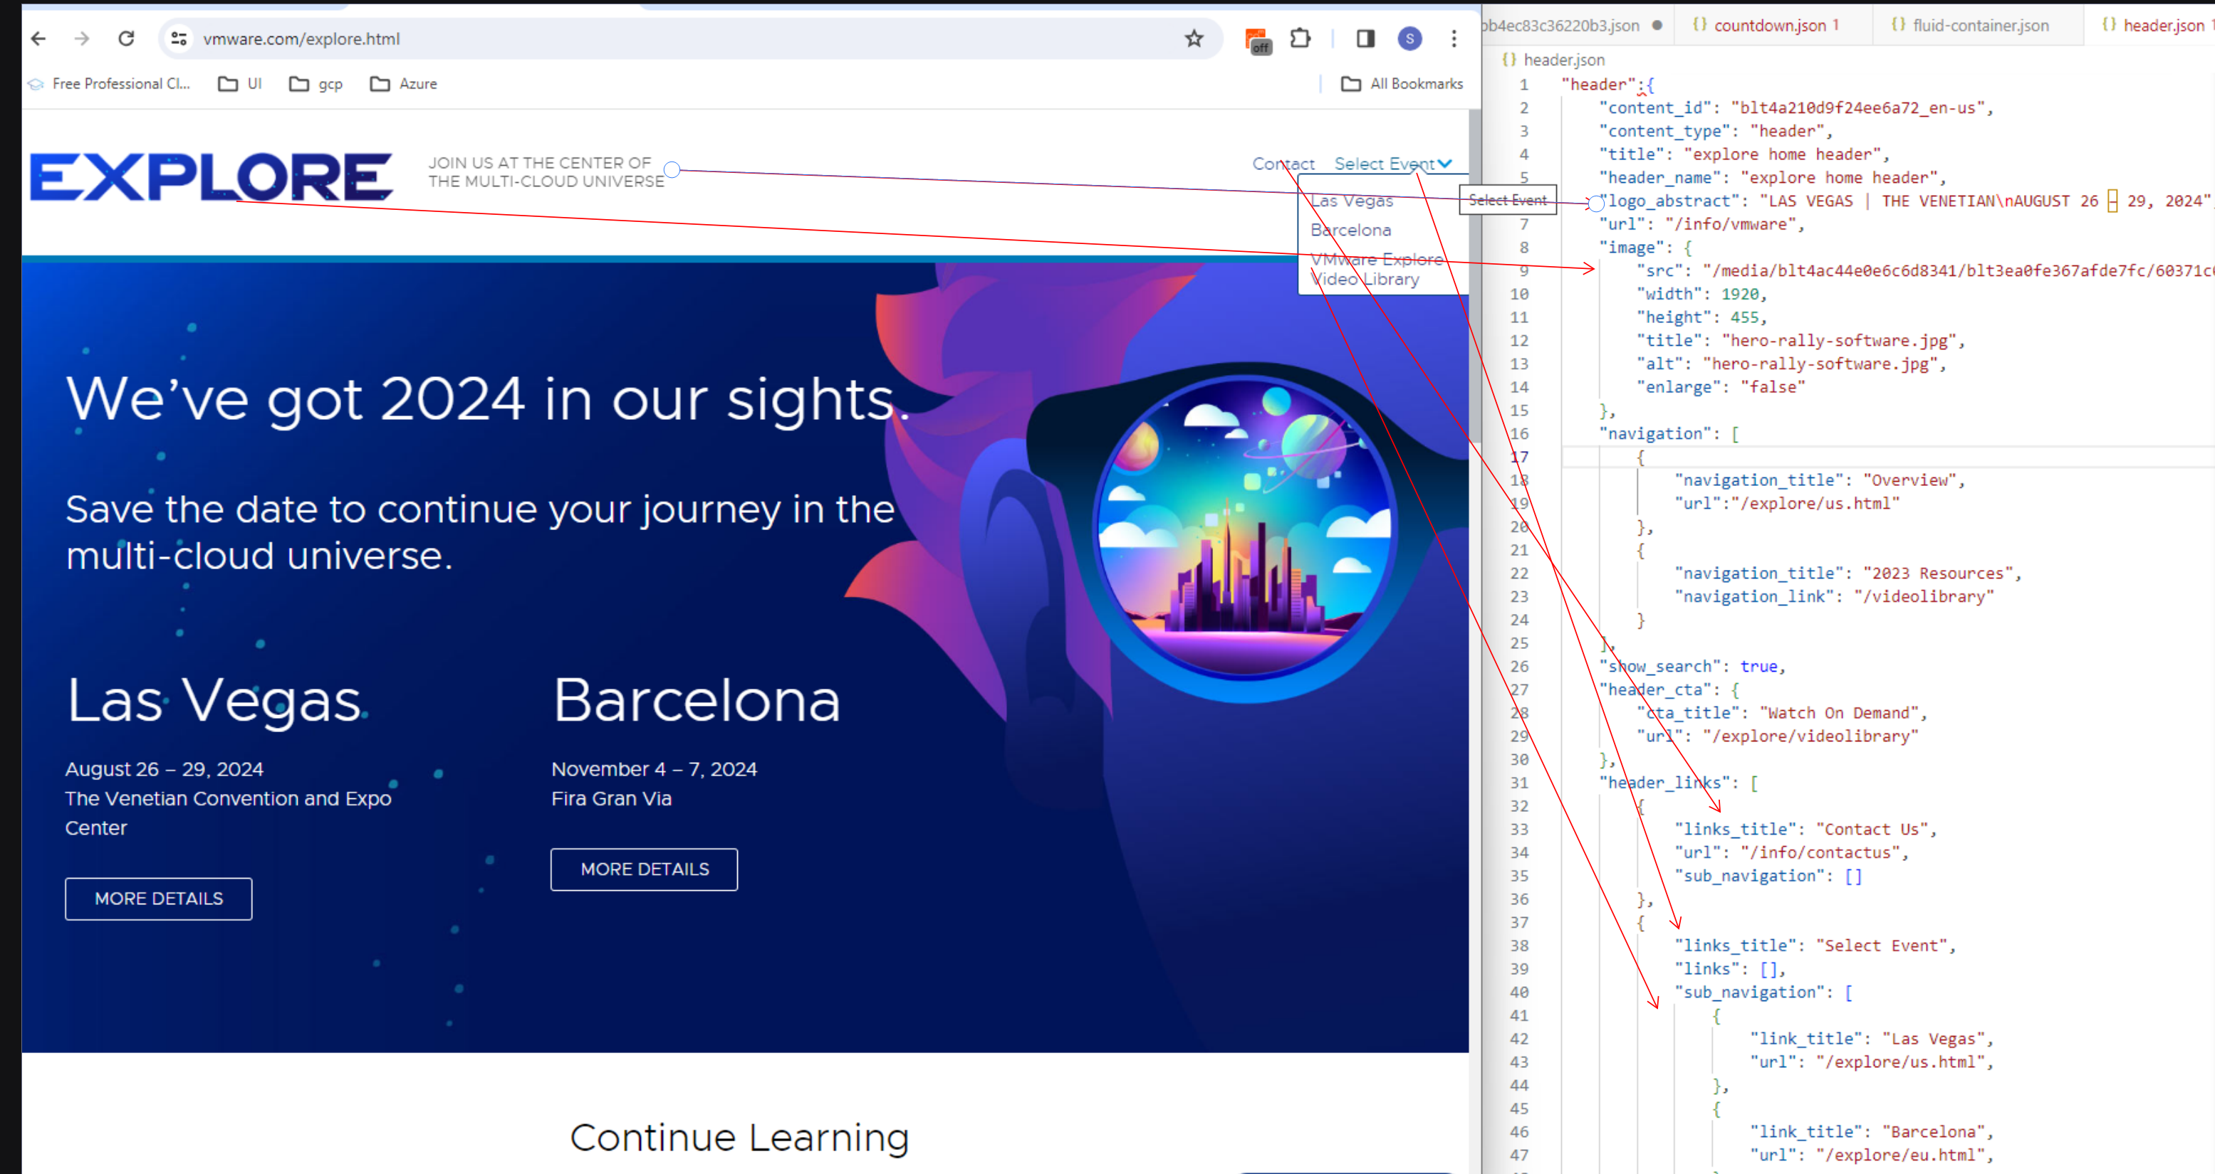

- Footer

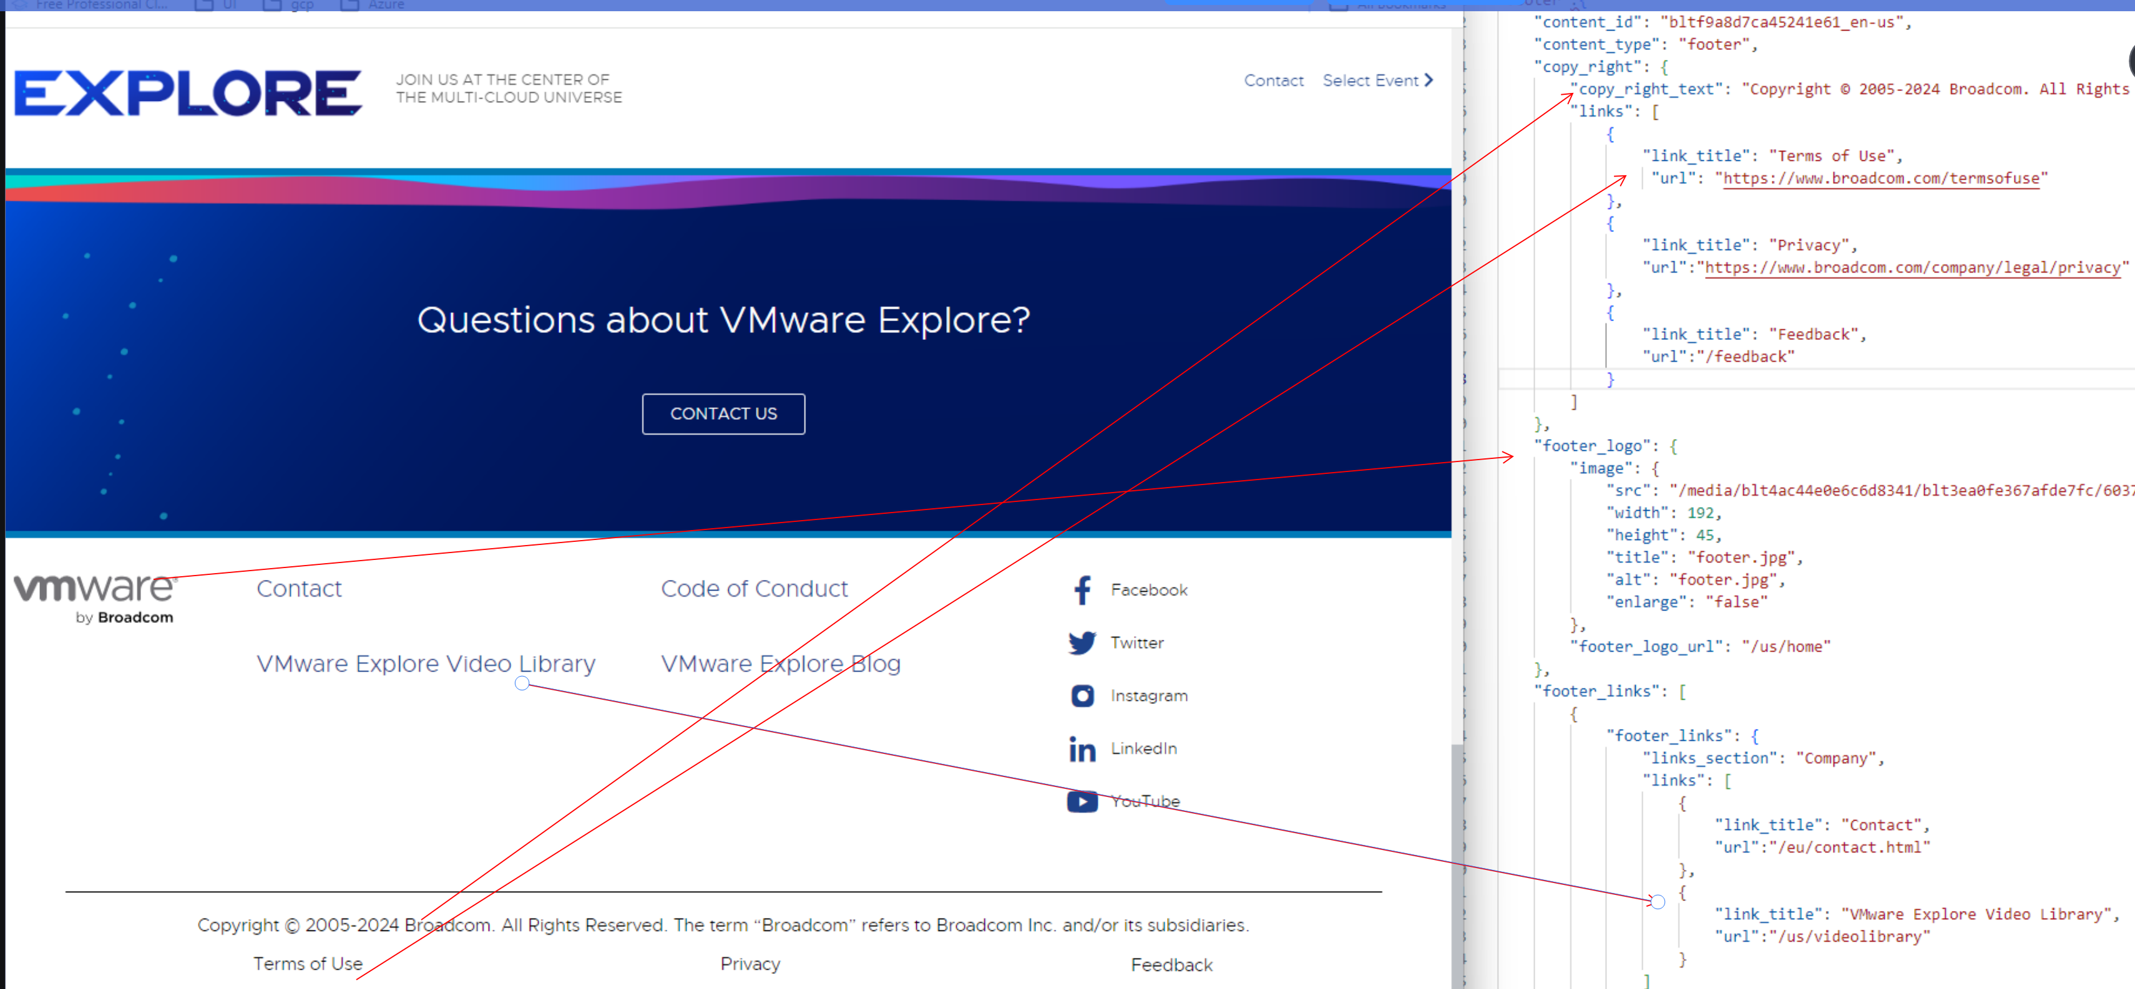

- Card:

- Carousel:

- Column Container: eg: https://www.vmware.com/products/vsphere.html
CS Content Type: Content Block List
Template: Lef Nav Block
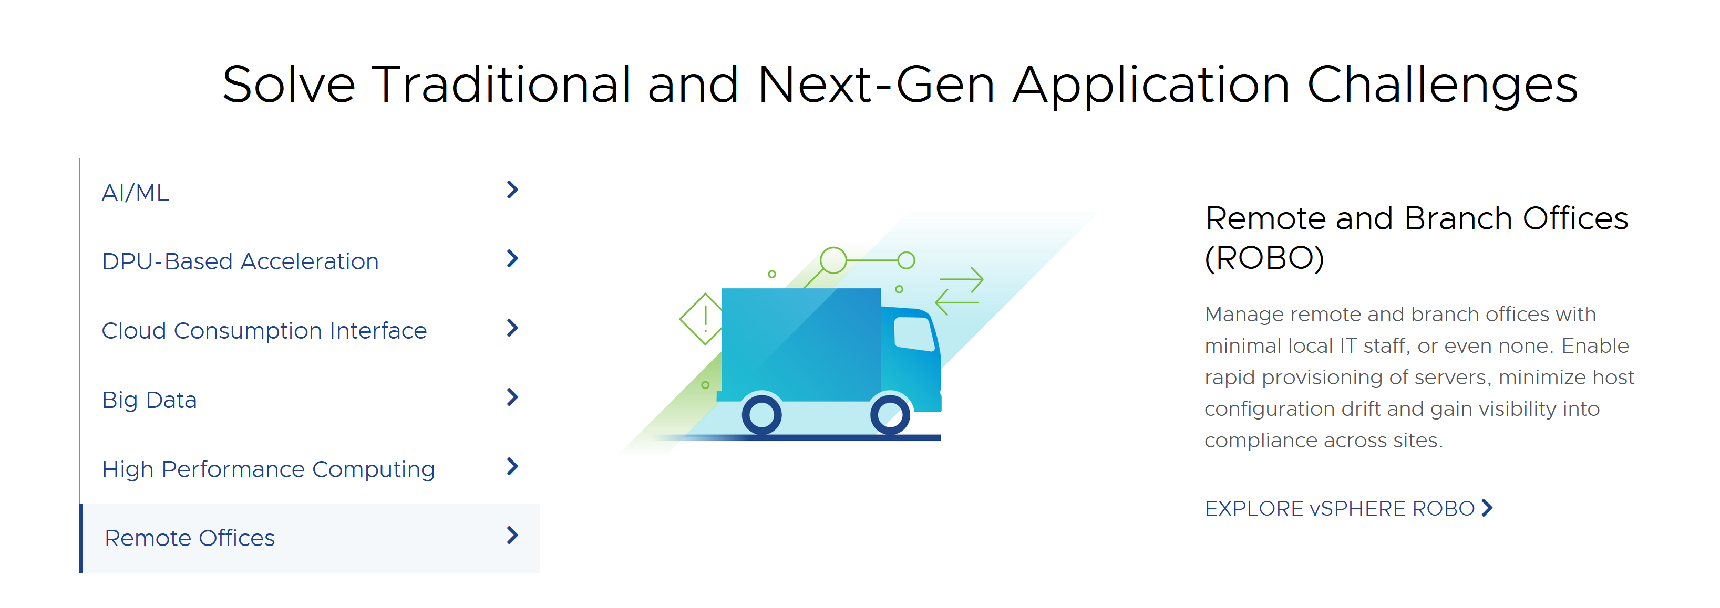

Template: Top Nav Block
https://www.vmware.com/vmware-explore-new.html
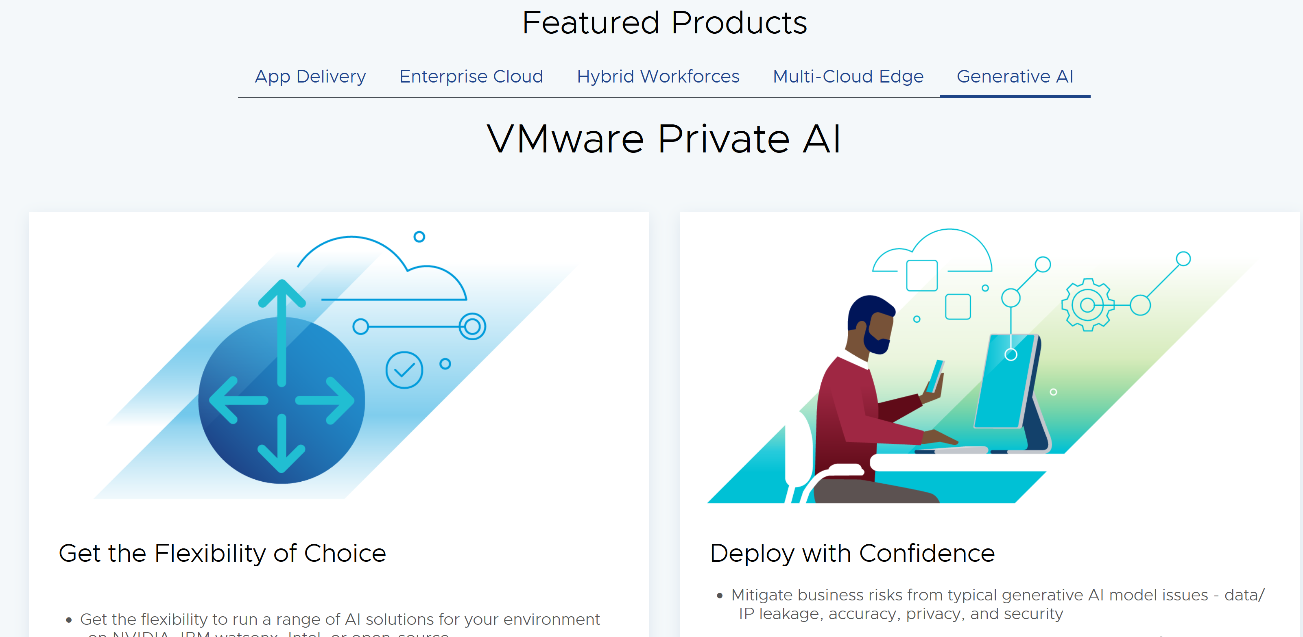

- Event Listing:
